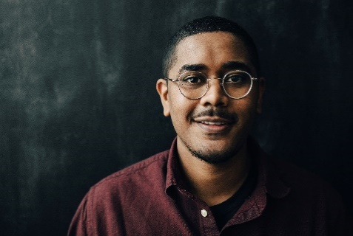**John Doe**

New Orleans, LA 70118

(504) 123-4567

ministry.professional@gmail.com

**PERSONAL INFORMATION**

* **Hometown:** Birmingham, AL
* **Ordination:** Victory Ridge Baptist Church 2021
* **Marriage:** Jane Doe 2020

* **Children:** Jack (3), Julie (1)

**EDUCATION**

**New Orleans Baptist Theological Seminary,** New Orleans, LA. 2022- Present

* Master of Divinity, Biblical Studies (in progress)

**University of Mobile,** Mobile, AL. 2020-2022

* Bachelor of Science, Biblical & Theological Studies, 4.0 GPA
* Magna Cum Laude, Academic Distinction
* School of Christian Studies Academic Achievement Award
* President’s Scholastic Award

**MINISTRY EXPERIENCE**

**Jones Road Baptist Church,** Dothan, AL. 2021-2022

* Pastoral Internship
* Weekly service review, service planning, and sermon preparation meetings
* Read weekly book assignments; met with pastors for discussion and discipleship

**Victory Ridge Baptist Church,** Mobile, AL. 2020-2021

* College Ministry Assistant
* Wednesday night teaching, service preparation, and planning
* Discipled male college students; led discipleship groups; individual meetings

**EMPLOYMENT HISTORY**

**NOBTS, New Orleans, LA.** 2024-Present

* Financial Aid Counselor
* Meeting prospective students, provide information about NOBTS scholarships, assist students through the application and admission process
* Weekly tasks include calling scholarship recipients, compiling completed applications, managing G.I. Bill correspondence, etc.

**Calvary Academy,** Montgomery, AL. 2022 - 2024

* Biblical Studies Instructor (remote)
* Courses instructed: Theology, Christian Worldview, OT Survey, and NT Survey
* Aiding curriculum development team in lesson creation and future planning

**Holiday LawnCare,** Tuscaloosa, AL. 2017 - 2019

* Foreman for a commercial lawn route
* Trees, sod, and other landscaping duties; operated and serviced equipment as needed

**Magnolia Carpentry,** Tuscaloosa, AL. 2016-2019

* Owned and operated carpentry business; managed bookings, rented shop, finances, and paid employees

**MISSIONS/EXTRACURRICULARS**

**Provo, Utah** 2020-2022

* Helped plan and lead four ministry trips to the Salt Lake Valley while working in Victory Ridge College ministry
* Ministered to Mormon students at BYU, UVU, and WS through a dialogue program; trained evangelical students for LDS evangelism; supported local church partnerships and church plants

**Paris, France** Summers 2017-2019

* Evangelism and discipleship for middle-school-aged students
* Trained and encouraged local church pastors in rural areas

**University of Mobile**, Mobile, AL.

* University of Mobile Ambassador 2021-2022
* Intramural Staff 2020 – 2022
* Residential Assistant 2020
* Bible study leader 2021-2022

**REFERENCES**

* **Dennis Jackson**, Victory Ridge Baptist Church (234) 734-1279

* **Guy Rose**, Jones Road Baptist Church (257) 507-9905
* **Dr. Jude Kelly**, FBC Montgomery (521) 329-7891
* **Dr. Tony West**, Dean, UM School of Christian Studies (391) 593-1001